**Singleton Questions**

1. The general purpose of the Singleton pattern is to:
2. Ensure that no more than one instance of a class exists.
3. Ensure that only one instance of a class exists at the same time.
4. Separate objects in a single class from objects in another class.
5. Control creation of objects in a single class or another class.
6. Which of the following is true about Singleton class?
7. The class has only a single member method.
8. The class has only a single field.
9. The class should have exactly one instance.
10. The class cannot be sub-classed.
11. Implement three Singleton classes in Java.
    1. Using eager initialization
    2. Using lazy initialization
    3. Thread safe version

Solution:

<https://github.com/ishaqait/DesignPattern.git>

1. Implement the Factory using the given class diagram, in JAVA:

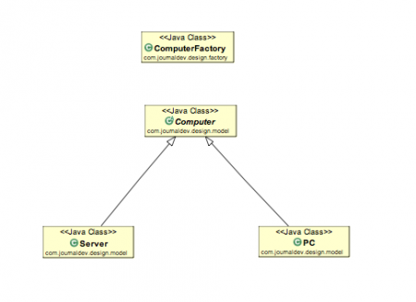

Solution:

https://github.com/ishaqait/DesignPattern.git